13. Create a template in AEM

What is a template?

Template is a blueprint or layout to create a page in AEM, it provides a consistent page structure throughout the website. Template is use to create a page.

It has a properties label, name, description, resourceType, ranking and allowedPath.

Label - becomes the node name,

Title - we can see in the console while creating the page,

Description - describes what template is all about,

Ranking - provides the order in which template will display,

ResourceType - is use to point towards the page rendering component,

AllowedPath - gives the path where this Template can be used.

Template is associated with the page rendering component and it has no content.

Steps to create template:

1. Right click on **templates** folder that we created earlier and select **create template** option from the list.
2. Fill in the details as shown below.
3. ResourceType is the page component path to which this template points to.

(When this particular template is used to create any page, the script that is defined in the page component path will be executed and brings the content on the page).

/content(/.)? – is the regular expression which allows this template to use anywhere inside /content.

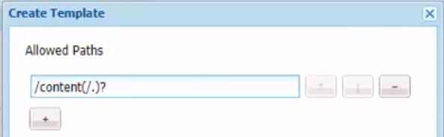

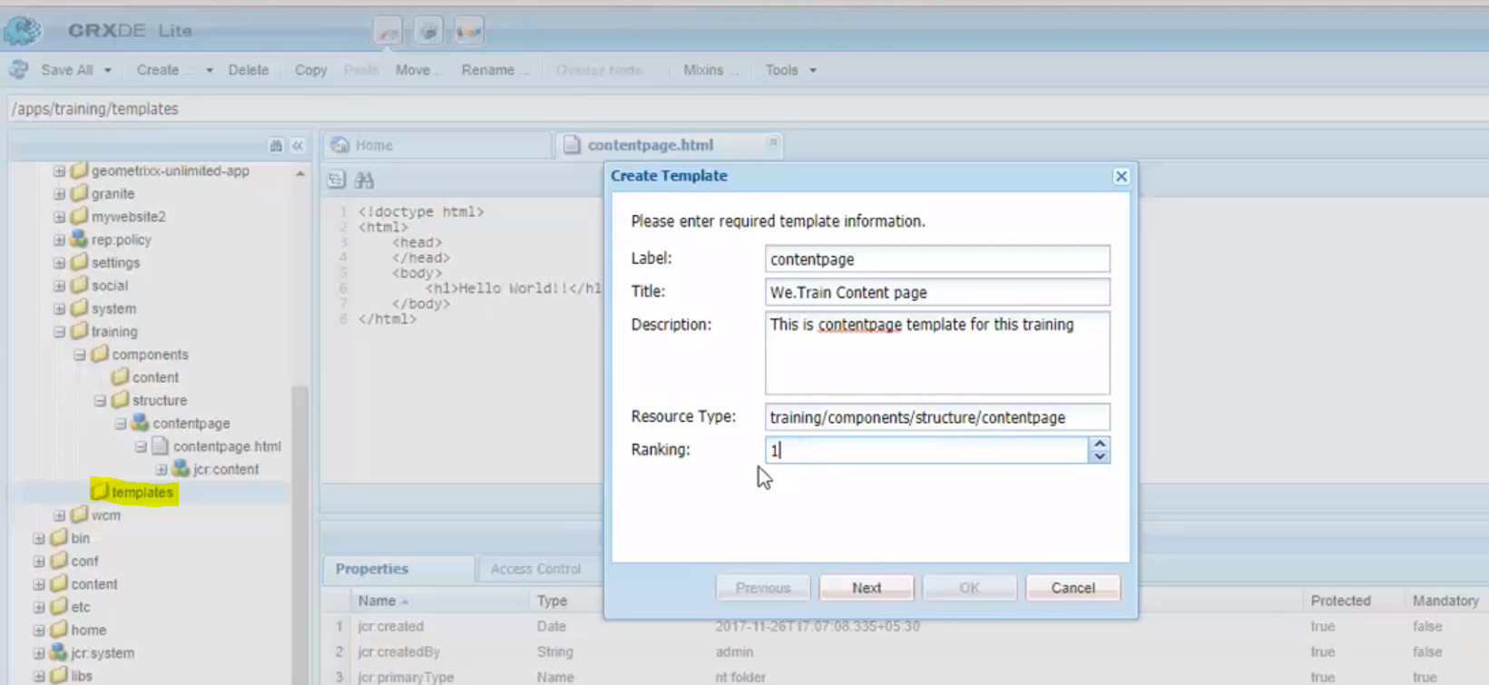

1. Click on Next and Ok.

Testing:

Go to Sites -> Click on Create -> Page -> Select the template -> Provide the values -> Click on Create-> Done

Page will be created with the name that we provide.

Click on the page -> Edit -> This will open the page in edit mode with default content that we have create in page component HTML.

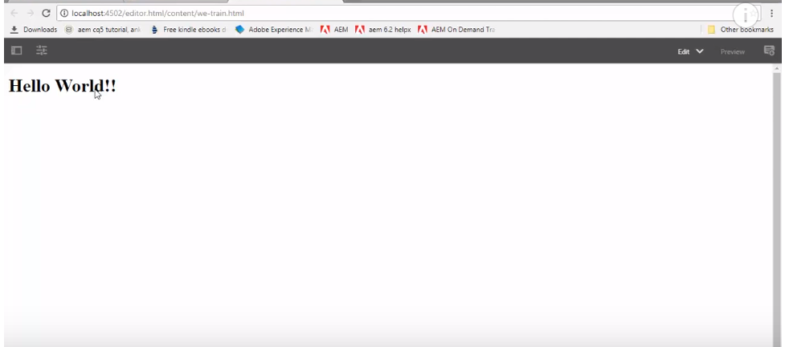

**Trouble shooting:**

If the page is loaded empty, then go check the sling:resourceType property value under template jcr:content node.

This should be pointing to the correct page component path.

